**Decision Tree Classifier :**

If the data we are dealing with is qualitative or categorical , then also decision trees are proved to be powerful. Decision Tree Classifiers make use of a series of calculated questions regarding the attributes of the test record, for each returned value a follow-up question is asked and hence the splitting is performed from the attributes of the data . This is done until a conclusion about the class label of the record is reached. The difference between the working of a classification and a regression tree lies in the criteria taken for performing a split.

While decision tree regressors use RSS criteria , Classification trees calculate and use 3 criteria for splitting the nodes , **Classification error rate , Entropy and Gini impurity**.

Let us now learn about each of them separately.

**Understanding the Algorithm working behind :**

Before discussing the criteria , let us briefly talk about the overview of working of a classification tree for a better understanding about why they are needed.

So the algorithm of building of a decision tree is recursive in nature. At each step, a decision has to be made for further splitting till the last node (leaf node). The decision is based on some question which has an answer in either **True** or **False**, and as the response of these questions, we make a split. The algorithm decides **which question to ask and when**. So we keep narrowing down the data in the form of a tree arranging and **distributing** it according to it’s classes or label. Now since the data is arranged according to classes, whenever any unknown data is given the tree, it can be easily **navigated** through the tree to predict it’s **class** or label.

So as discussed, the critical point is deciding **which question to ask and when**. Basically, every node gets the list of columns(or features) of the dataset as input.

So ‘the best question to ask’ is selected by calculating ‘how much an attribute will contribute towards distribution into classes’, (calculated by **Gini Impurity and Entropy).** Further by using another value of ‘how much of the impurity is reduced’ (calculated by **Information gain)**, we can decide which attribute/feature should be taken as the node to split and proceed further.

This calculation and selection procedure keeps happening in a recursive fashion till the whole tree is built.

So now we are ready to understand the criteria in more depth with an example data:

**Entropy :**

Entropy is the measure of randomness in the data. In other words, it gives the impurity present in the dataset. It tells us how much the data is discorded into different classes at a given point.

Here is the Mathematical Representation of Entropy :

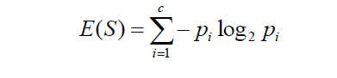

Where **c** is the no. of classes and ‘p’ at every point(for each class) is the probability of that class.

Suppose we are dealing with a data with **n** observations to classify it into 2 categories: **A** or **B.** Let the no. of instances of class **A** be **x.**

So we have **c** =2 , **p1**= x/n and **p2** = n-x/n . In this case the Entropy **E** can be obtained as :

E = -p1*log2(p1) – p2*log2(p2)

Here is the graphical representation of Entropy :

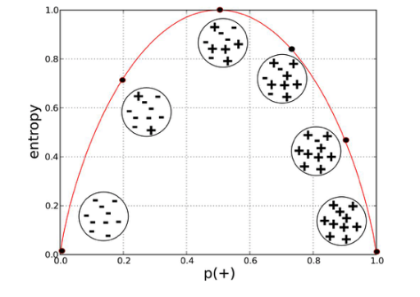

If we compare the graph with the example we discussed above, we can figure out that Entropy is Maximum when probabilities for both classes are Equal, and 0 when probability is 0 or 1 this also validates that the entropy is the amount of disorder(or mix-ups) in the data.

**Information Gain :**

Information gain is the measure the decrease in entropy after splitting a node. It is the difference between entropies before and after the split. The more the information gain, the more entropy is removed. Significantly, it helps to calculate importance and ordering of the attributes in the nodes.

Here is the mathematical representation of Information Gain:

**Gain(R,C) = Entropy(R) – Entropy(R,C)**

Here, R represents the root node of the tree and C represents the child obtained after splitting the node R.

**Gini Impurity :**

Gini impurity is the measure of possibility of a new random data to be classified wrong if that new instance were randomly classified according to the distribution of class labels from the data set.

It is calculated by multiplying the probability that a given observation is classified into the correct class and sum of all the probabilities when that particular observation is classified into the wrong class.

Here is the mathematical representation of Gini Impurity:

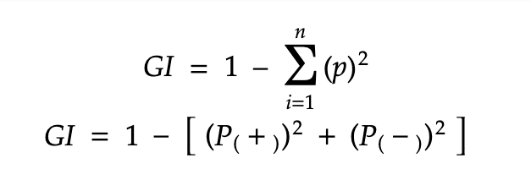

Where **n** is the no. of classes and ‘p’ at every point(for each class) is the probability of that class.

Suppose we have 2 classes **+** and **-** , then we can calculate the Gini Impurity as follows:



**Example and Calculation:**

Now let us take all the concepts from above and frame them into an example to solve a problem!

Before proceeding further, Let us define few terms used below:

* **Root Node –** The First node of the tree having the highest hierarchy
* **Leaf Node –** The nodes at the end of the tree which don’t have any child
* **Pruning -** Tree pruning is the method of trimming down a full tree (obtained through the above process) to reduce the complexity and variance in the data.
* **Internal Node -**

**The Camera Data :**

This dataset contains 3 column in which the purchased is the target feature

* Camera 🡪 No of camera in a mobile phone
* Gender 🡪 Gender (male or female)
* Purchased 🡪 whether the person purchased the phone with the specified camera count or not

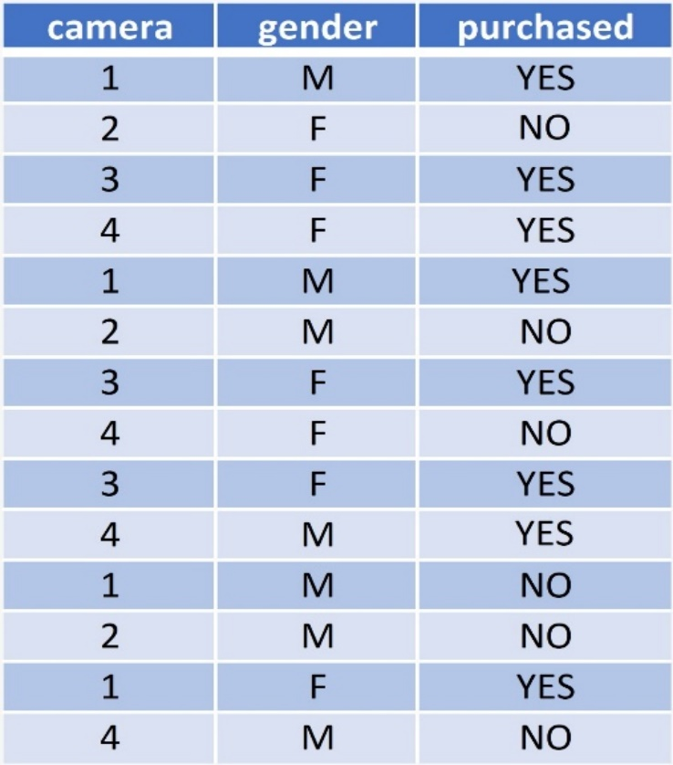

**We will use both Gini Impurity and Entropy as the criteria one by one to find the root node for building the tree, for clear comparison and understanding**

* **Gini Impurity of Camera Feature :**

Let us start by calculating Gini Impurity of the feature **Camera.**

For calculating probability we can arrange the entities of camera feature in the data like this:

|  |  |  |  |
| --- | --- | --- | --- |
| Camera | Purchased | P(YES) | P(NO) |
| 1 | **Yes -3 | No-1** | **3/4** | **1/4** |
| 2 | **Yes -1 | No-2** | **1/3** | **2/3** |
| 3 | **Yes -2 | No-1** | **2/3** | **1/3** |
| 4 | **Yes -3 | No-1** | **3/4** | **1/4** |

The camera feature has 4 unique values, therefore we can calculate Gini for each type of value and further calculate a weighted Avg as the Gini impurity of camera feature

**G(Camera 1) = 1 – P(YES)]2 - [P(NO)]2**

**= 1 – ()2 – ())2**

**= 0.375**

**G(Camera 2) = 1 – P(YES)]2 - [P(NO)]2**

**= 1 – ())2 – ())2**

**= 0.444**

**G(Camera 3) = 1 – P(YES)]2 - [P(NO)]2**

**= 1 – ()2 – ()2**

**= 0.444**

**G(Camera 4) = 1 – P(YES)]2 - [P(NO)]2**

**= 1 – ()2 – ()2**

**= 0.444**

* **Weighted Sum of Gini Impurity for Camera feature :**

**G(Camera)** = $\frac{n * (Cam 1) }{m}$* G(cam 1) + $\frac{n * (Cam 2) }{m}$* G(cam 2) + $\frac{n * (Cam 3) }{m}$* G(cam 3) + $\frac{n * (Cam 4) }{m}$* G(cam 4)

= (0.2857 * 0.375) + (0.2142 * 0.444) +(0.2142 * 0.444 )+ (0.2857 * 0.375 )

=0.4044

Therefore, **Gini Impurity** of **camera** feature **= 0.4044**

* **Gini Impurity of Gender Feature :**

Now let us calculate Gini Impurity of the feature **Gender.**

For calculating probability we can arrange the entities of camera feature in the data like this:

|  |  |  |  |  |
| --- | --- | --- | --- | --- |
| Gender | Purchased | N | P(YES) | P(NO) |
| M | **Yes -3 | No-4** | **7** | **3/7** | **4/7** |
| F | **Yes -5 | No-2** | **7** | **5/7** | **2/7** |

Since the gender feature has 2 unique values, therefore we can calculate Gini for each type of value and further calculate a weighted Avg as the Gini impurity of **gender** feature

**G(MALE) = 1 – P(YES)]2 - [P(NO)]2**

**= 1 – (3/7)2 – (4/7)2**

**= 0.489**

**G(FEMALE) = 1 – P(YES)]2 - [P(NO)]2**

**= 1 – (5/7)2 – (4/7)2**

**= 0.408**

* **Weighted Sum of Gini Impurity for Gender feature :**

G(Gender) = $\frac{n * (Male) }{m}$* G(Male) + $\frac{n * (Female) }{m}$* G(Female)

= (0.5 * 0.49) + (0.5 * 0.408)

= 0.449

Therefore, **Gini Impurity** of **gender** feature **= 0.449**

**On comparing we find Gini(Camera) < Gini(Gender), therefore Camera is selected as the root node**

**Now**, Let us find the root node by calculating Entropy:

* **Entropy of the whole Dataset :**

**(This will be used further for calculating entropy of particular features)**

**E(S) = - P(YES)* log2 (P(yes)) - P(NO)* log2 (P(NO))**

**= -**

**= -[0.57 * (-0.81) + 0.428 * (-1.22)]**

**= 0.462 + 0.5228**

**= 0.985**

Since the Camera feature has 4 unique values, therefore we can calculate Gini for each type of value and further calculate a weighted Avg as the Entropy of **Camera** feature

**E(camera 1 ) = $\frac{3}{4}*log(\frac{3}{4})$- $\frac{1}{4}*log(\frac{1}{4})$**

**= - [0.75 * (-0.12) + 0.25*(-0.602)]**

**= - [-0.09 – 0.150]**

**= 0.240**

**E(camera 2 ) = - $\frac{1}{3}*log(\frac{1}{3})$- $\frac{2}{3}*log(\frac{2}{3})$**

**= - [0.333 * (-0.4777) + 0.666*(-0.176)]**

**= - [-0.158 – 0.115]**

**= 0.275**

**Similarly we can calculate, E(Cam 3) = 0.275 and E(Cam 4) = 0.240**

**Weighted Sum of Entropy for Camera feature :**

**E(G) = $\frac{4}{14}$* (0.240) + $\frac{3}{14}$* (0.275) + $\frac{3}{14}$* (0.275) + $\frac{4}{14}$* (0.240) = 0.252**

So, **Entropy** of **camera** feature **= 0.252**

Therefore**, Information Gain** for **Camera : = 0.985 – 0.252 = 0.733**

Since the gender feature has 2 unique values, therefore we can calculate Gini for each type of value and further calculate a weighted Avg as the Entropy of **gender** feature

**Entropy of Gender :**

**E(Male ) = - $\frac{3}{7}*log(\frac{3}{7})$- $\frac{4}{7}*log(\frac{4}{7})$**

**= -[0.428 * (-0.367) + 0.571* (-0.243)]**

**= - [-0.157 – 0.138]**

**= 0.295**

**E(Female ) = - $\frac{5}{7}*log(\frac{5}{7})$- $\frac{2}{7}*log(\frac{2}{7})$**

**= - [-0.104 – 0.155]**

**= 0.295**

**Weighted Sum of Entropy for Camera feature :**

**E(Gender) = $\frac{7}{14}$* (0.295) + $\frac{7}{14}$* (0.259)**

**= 0.5*(0.295) + 0.5*(0.259)**

**= 0.147 + 0.129**

**= 0.276**

So, **Entropy** of **camera** feature **= 0.276**

Therefore**, Information Gain** for **Gender : = 0.985 – 0.276 = 0.709**

**On comparing, we find I.G (Camera) < I.G(Gender), therefore Camera is selected as the root node**

From both comparisons, we conclude that **Camera** is the root node.